FORM 5
THE PATENT ACT 1970
(39 OF 1970) &
The Patents Rules, 2003
DECLARATION AS TO INVENTORSHIP
(See section 10 (6) and rule 13 (6))

1. Name of applicants: Mrs. Gavini Venkata Leela Kumari, Mr. Palaparthi Venkata Naga Srinivas, Gaddam Venu, Jeevan Devandla, Gulivindala Sri Lakshmi Sarojini, Doppalapudi Sri Sai Teja and Mudraboina Durgarao, Bapatla Engineering College hereby declare that the true and the first inventors of the invention disclosed in the complete specification filed in pursuance of my/our application numbered TEMP/E-1/49686/2026-CHE dated 09-04-2026 are
2. Inventors:

i). Name: Mr. Gavini Venkata Leela Kumari
Nationality: Indian
Address: Department of CSE (Artificial Intelligence and Machine Learning),
Bapatla Engineering College, Bapatla 522102, Guntur (Dt.), A.P.

ii). Name: Mr. Palaparthi Venkata Naga Srinivas
Nationality: Indian
Address: Department of CSE (Artificial Intelligence and Machine Learning),
Bapatla Engineering College, Bapatla 522102, Guntur (Dt.), A.P.

iii). Name: Gaddam Venu
Nationality: Indian
Address: Department of CSE (Artificial Intelligence and Machine Learning),
Bapatla Engineering College, Bapatla 522102, Guntur (Dt.), A.P.

iv) Name: Jeevan Devandla
Nationality: Indian
Address: Department of CSE (Artificial Intelligence and Machine Learning),
Bapatla Engineering College, Bapatla 522102, Guntur (Dt.), A.P.

v) Name: Gulivindala Sri Lakshmi Sarojini
Nationality: Indian
Address: Department of CSE (Artificial Intelligence and Machine Learning),
Bapatla Engineering College, Bapatla 522102, Guntur (Dt.), A.P.

vi) Name: Doppalapudi Sri Sai Teja
Nationality: Indian
Address: Department of CSE (Artificial Intelligence and Machine Learning), Bapatla Engineering College, Bapatla 522102, Guntur (Dt.), A.P.

vii) Name: Mudraboina Durgarao
Nationality: Indian
Address: Department of CSE (Artificial Intelligence and Machine Learning), Bapatla Engineering College, Bapatla 522102, Guntur (Dt.), A.P.

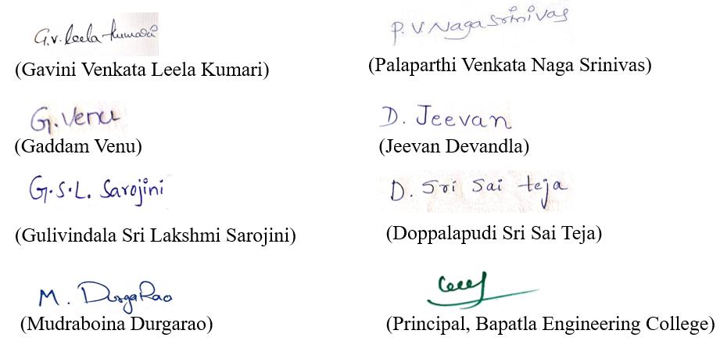

Dated this: 09-12-2026

To,
The controller of patent
Patent office at, Chennai.

